D.A.V Public School, Airoli
Date: 07/06/18

Dear Students,
Schedule for approval of FYJC Online admission is as follow:
(Division Wise & Roll No wise)

Date | Timings | Div | Roll No
11/06/18 | 9:00 am – 12.30 pm | A | 1- 50
 | 2:00 pm – 4:00 pm | B | 1-30
12/06/18 | 9:00 am – 12.30 pm | B | 31 - 51
 | 2:00 pm – 4:00 pm | C | 1 - 30
13/06/18 | 9:00 am – 12.30 pm | C | 31 - 48
 | 2:00 pm – 4:00 pm | D | 1-48
14/06/18 | ---------------------------------------------------------------------------------
15/06/18 | 9:00 am – 12.30 pm | E | 1-30
 | 2:00 pm – 4:00 pm | E | 31-47
16/06/18 | 9:00 am – 12.30 pm | F | 1-30
 | 2:00 pm – 4:00 pm | F | 31-50

Note:
- Form shall not be approved by the centre without mentioned documents in the booklet.
- Students are requested to adhere the schedule to avoid chaos and inconvenience.

Principal
D.A.V Public School Airoli

D.A.V Public School, Airoli
Online Admission FYJC 2018-19
Details / Documents required for Approval of FYJC Online Admission
- Our school will approve forms for OMMR (Outside Mumbai Metropolitan Region), OMS (Out of Maharashtra state) students and students who have passed class 10th from same school.
- MMR (Mumbai metropolitan region) students have to get the forms approved from their own school.
- Option form will be activated only after SSC result for selection of colleges.
- Index No. to be filled in form is Affiliation no. of School.
- For D.A.V Public School, Airoli Index No. is 1130069 & U-DISE No. – 27211001605

Documents to be submitted at the time of Admission

Open Category | Constitutional Reservation  (SC/ST/VJA/NTB/  NTC/NTD/OBC/SBC) | Special Reservation
1) Original Mark Sheet  (S. S.C. or equivalent)  2) Original School Leaving  Certificate | 1) Original Mark Sheet  (S.S.C. or equivalent) 2) Original School Leaving  Certificate  3) Caste Certificate | 1) Original Mark Sheet  (S.S.C. or equivalent)  2) Original School Leaving  Certificate  3) Special Reservation  Certificate

Constitutional Reservation : Caste Certificate issued by the competent authority appointed by the State of Maharashtra (if applicable). Please note that the quota against constitutional reservations is available only to the applicants originating & domiciled in the State of Maharashtra. (It is not available for applicants originating from outside the State of Maharashtra.)

For Sports : Applicants should possess any one of the following certificates obtained while studying in standards VIII, IX, or X as per government resolution dt. 26th June 1997
- Certificate showing that the student has secured first or Second position at the District/ State/National level.
- Certificate showing that the student has won Medal at the zonal level or the certificate showing that the student has participated in the State/National level competitions organized by the Indian School Games Association or Indian Games Authority.
- Certificate showing that the student has won Medal at the State level or the student has participated in the State/National level competitions organized by the Indian Olympic Association or Maharashtra Olympic Association.
These certificates should be authenticated by district Sports Officer or Regional Deputy Director (Sports) in prescribe form given below.

Specimen of Authorised Certificate
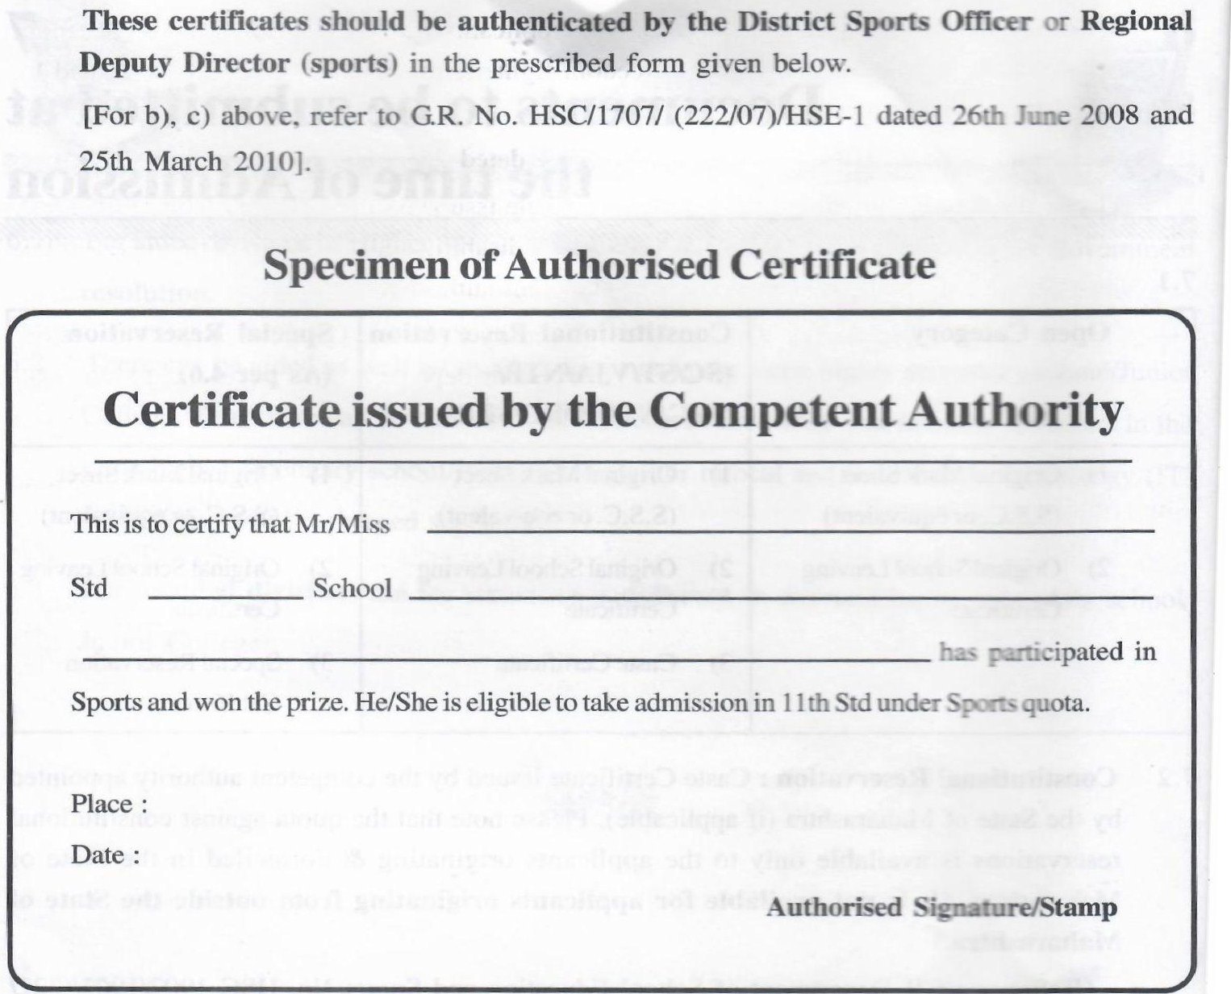
  - Wards of the Employees of State Government/Central Government private Sector coming on transfer in the corporation online admission area (if applicable original Certificate showing transfer of the employee from outside corporation online admission area to corporation online admission area on or after 1 ^{st} October 2017. the ward must have passed Std. X or equivalent examination from a school outside corporation online admission
  - Wards of Serviceman and Ex-Serviceman (if applicable):
i) For Serviceman: Service Certificate.
11) For Ex-Serviceman: Discharge Certificate or Certificate issued District Sainik Board.
  - Wards of Freedom Fighters (if applicable): Applicants who are dependent on the freedom fighters and are so nominated by the freedom fighters, must submit a certificate issued by the District Collector to that effect.
  - Physically handicapped (if applicable): Certificate issued by the Civil Surgeon or the Dean of any Government hospital, showing at least 40% disability. Students with learning disability must produce a certificate issued by the competent authority.
  - Project Earthquake Affected : Certificate issued by Collector/District Rehabilition officer stating that project affected or earthquake affected or dependent for employment/admission required to be attached/approved to avail this reservation under this catogory.
Note:
- Any of the quota form shall not be approved by the centre without above mentioned documents.
- Students / Parents without Valid/ Incomplete documents/ forms shall not be approved by the centre.
- The process for approval of form shall begin after declaration of result by CBSE & as per the schedule given on https://mumbai.11thadmission.net/

Timings: 9.30 a.m. – 12.30 p.m.
2.00 p.m. – 03.30 p.m.

